Big Mountain Report

Based on the models developed, the data shows that currently Big Mountain is undercharging for their ticket prices and from there exist a few options for reducing operation costs. First, one assumption to note is that the ticket prices gathered from all other resorts are priced accurately/reflective of the market. Secondly, there is a lack of provided information (i.e. operation costs for chairlifts, snow making devices, costs of creating more/ and lengthening trails) for the cost analysis of the four proposed options 1) Closing up to 10 of the least used runs 2) adding a run, increasing vertical drop by 150ft and installing additional chair lift 3) similar to option 2, but with added 2 acres of snow making 4) increasing the longest run by 0.2 miles and adding 4 acres of snow coverage making capability.

Current ticket price of 81$ for Big Mountain ski resort is less than minimum predicted possible value for ticket price. From the data extracted across the U.S. for ski resorts, it’s predicted that the price could be $95.87 per ticket with an mean absolute error of $10.39. Factoring for the worst case error, that still leaves a minimum price that Big Mountain could charge per ticket to be $85.48. Located in the state of Montana, various other ski resorts pale in comparison via price as shown in figure 1. However, other resorts in the states lack in the department of features that economically drive the price of the ticket. Looking at the figure 2, Big Mountain actually isn’t charging a price that is abnormally high due to the histogram showing how Big Mountain is somewhere in the mid to upper price ranges.

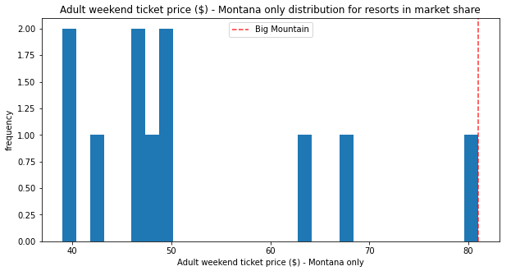

*Figure (1): Montana Ski resort ticket prices histogram; red line is Big Mountain Resort*

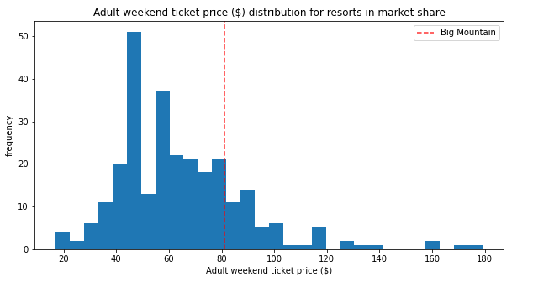

*Figure (2): U.S. Ski resort ticket prices histogram;red line is Big Mountain Resort*

Of the four listed options, (1) and (2) are the ones with an impact that would make sense to implement financially.

It was found that closing runs in option 1 would result in a drop in ticket prices. This drop would be consistent for certain bands of least runs closed. When the least used run is closed, there is no price impact for tickets, closing 2 to 5 least used runs would result in a ticket price drop of $0.75, closing 6 to 8 least used runs would result in a ticket price drop of $1.25, and for 9 and 10 runs closed it would be ~$1.75. In an attempt to drop operation costs, other parameters would need to be evaluated, i.e. is the drop in revenue from ticket price less than the amount saved from closing the respective amount of runs to save on operation costs? Shown below in figure 3 are the modeled results indicating the respective drop in ticket price with number of runs closed.

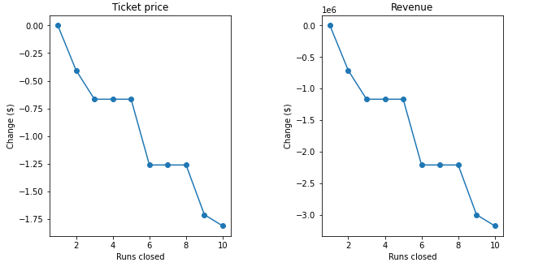

*Figure (3): Closing of runs up to 10 least used affect on ticket price*

Option 2 of adding a chair lift, increasing the vertical drop would add the appeal of Big Mountain Ski Resorts on features that actually drive the price of the ticket to go up! Option 2 if implemented would allow for the price of ticket to be increased up to $1.99 per ticket! Whether this makes sense to implement, data on the construction cost and operation cost of the chair would need to be considered for the return on investment.

Option 3 and 4 are now financially feasible ideas as they do not add more value to Big Mountain than the above two mentioned options. Option 3’s difference of adding more snow coverage does not drive the ticket price to be any higher than Option 2, so it’s likely this will only incur more operation costs. Lengthiest run is a metric that is not a driver for ticket prices, so when exploring option 4, the incurred cost would not financially benefit Big Mountain at all.

In the future if other parameters are to be explored on ticket prices, it would be ideal to consult for a script that would be able to take input of various variables and output the data of whether the ticket price would increase or decrease!